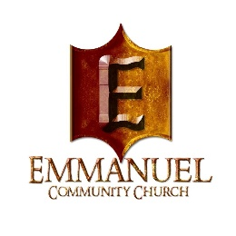
Emmanuel Community Church
Dr. Eric Suddith, Pastor

SPRING 2023/ SCHOLARSHIP APPLICATION PACKET

2024 /Spring Scholarship Award
Open Enrollment Date: January 7, 2024

Emmanuel will award Academic Scholarships for the Fall and Spring Semesters. The scholarship amount for each semester will be based on the availability of funds.

Eligibility Requirements
To be eligible, students must:

- Be a member of Emmanuel Community Church between the ages of 17-22 and be currently active in the Bold Ministry/Sunday School/Online Learning Classes and/or Wednesday Bible Study. New student members must have completed New Members Classes and actively participating in ECC ministries over a 6-month period of time.

- While in college, be active in Bible Study and or Sunday school (online). Parents who are members must be currently active in Sunday school prior to the scholarship if a student is away at school and can’t participate online.

- Have completed the requirements for a high school diploma by the Georgia Department of Education or must have earned a GED (General Equivalent Diploma) from an accredited school.

- Be transitioning into an accredited 4-year College/ University or 2-year Junior College in the upcoming semester or quarter.

- Student must be enrolled full-time (at least 12 semester hours) to receive a full scholarship or part-time (at least 9 semester hours) for a partial scholarship.

- Have a 2.0 GPA or higher per semester/quarter. An official transcript from High School scanned or a transcript printed from the official Educational Institution portal must be provided.

- Submit a completed Emmanuel Scholarship Application Packet electronically on or before the designated submission deadline.
ESSAY QUESTION REQUIRED: (Exempt if you submitted one in the FALL SEMESTER ‘2023)

QUESTION: In what areas of your life you have put that which is secular too close to (or in place of) the sacred? Regarding entertainment, secular spirituality, attitude toward money, etc. What guardrails can you erect to prevent this?

How to Apply

Eligible students must submit a completed application:

DOCUMENTS TO INCLUDE IN THE PACKET:

- Student Information Form
- Affirmation of Attendance (Small Group Classes)
- Typed Essay (written guidelines must be followed)
- Proof of High School (official) transcript of Grades and Diploma/or GED (Apply to High School Senior only)
- Letter of acceptance to college/university
- (Returning College Student) must provide current proof of enrollment (Class Schedule). An official transcript of GPA from previous semester/quarter.
- Incomplete or late applications will not be accepted. NO EXCEPTIONS

Scholarship Funds Disbursement Procedure

Scholarship recipients will receive confirmation via email, mail or text. Check will be mailed to the student’s school address or parent/guardian’s address on a designated date.

WHERE TO SUBMIT THE APPLICATION PACKET:

The completed Application Packet should be properly submitted and emailed to eccscholar2@gmail.com before the deadline date.

DEADLINE DATE: January 28, 2024.

Please Note: Student(s) enrolled in less than twelve (12) hours in College/University will receive a partial scholarship.

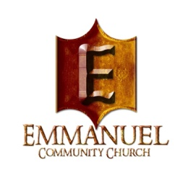

Emmanuel Community Church

Dr. Eric Suddith, Pastor

SPRING 2024 STUDENT INFORMATION FORM

Name: _________________________________________________

Are you currently a member at ECC? Yes ☐ No☐
Are your Parents Members of ECC? Yes ☐ No ☐

Student Cell #: ____________________ Parent(s) Home Phone # __________________

Student Email Address: ______________________________________

Parent (s) Name: _________________________________________________________

Address: ___________________________________________________________

City: _______________________ State: ___________________ Zip: _________

Name of College/University/ Attending:

______________________________________

Student ID #: _____________________________________

Major: _________________________________________

Minor: _________________________________________

College/University/ Address:
_______________________________________________________

________________________________________________________

***Application Check List:

- Completed form above (Student Information Form)
- Signed “Affirmation of Attendance” (for Sunday school/ Bible Study or Online Learning Classes).
- All essays are to be typed (500 words minimum) 12pt. font - Times New Roman double-spaced on 8 ½ x 11 size paper) Essays are to be properly written with correct use of grammar.
- Official Transcript (must be current).
- Proof of current enrollment in College/University.

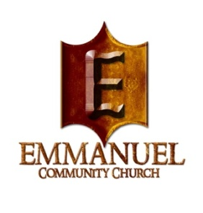

Emmanuel Community Church

Dr. Eric Suddith, Pastor

Affirmation of Attendance

My Name is _________________________________, and I am applying for an ECC Scholarship for College/University.

In order to qualify for this scholarship, I understand that I must be participating via ZOOM or whatever online platform is used by the Emmanuel Community Church (Small Groups Attendance, Bold Ministry and/or Wednesday Night Bible Study). This means that I am almost always participating and learning more about God and His work through our Lord and Savior Jesus Christ.

Please sign below that you can verify that I am almost always actively participating in the online Small Group Attendance. If, I have already moved away from my parents home (while attending college) and can no longer attend or participate in person. I promise to continue to connect with the online Small Group Attendance while in college and during my college breaks... and when I am in town.

Please affirm that I was almost always actively participating in your Small Group Classes when I was locally living at home and online while I was away at school.
____________________________ ________________________________________
(Print) Name of Student (Print Name) TLC Leader/ Facilitator

____________________________ ________________________________________
(Signature) Student (Signature) TLC Leader/Facilitator

_________________________ ___________________________
Date Date

